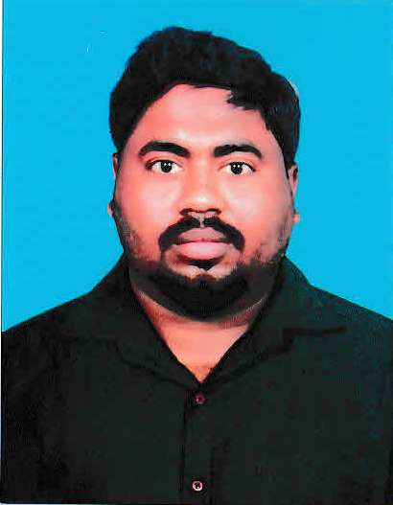SUROJIT RANA

No-4, Indira street,nazarathpet,

TamilNadu,600123

* +919789025308

surojitrana88@gmail.com

CareerObjective:

Self-Motivated and enthusiastic Engineer, willing to Work in an Innovative and competitive environment. Having 3 years of experience in Production Engineering & 2 years of experience in Quality Residential Engineer at KIA India Ltd & 2.5 years in Machining Quality Control department.

**CompanyProfile:**

**MandoAutomotiveIndiaPvt.Ltd**, Chennai,India.Manufacturersawiderangeofhigh-qualityandadvanced Steering systems, Brakes, Shock absorbers, Struts & ABS units for cars. Its premium**customers**areHyundai, TataMotors, KiaMotors, Mahindra, Isuzu,andmanymore.

**Experience:**

28thAug2014–Tillnow

2014 - 2015 :TechnicalApprentice

2015 - 2016 :OperatingEng.

2016 - 2018 :SenioroperatingEng.(cellleader).2018 – 2022 : Junior Eng (Quality- Machining)

**Measuring Instruments Knowledge:**

* CMM (Calypso – ZEISS)
* Contour Graphy& Surface Roughness Tester
* Video Inspection System (TESA)
* Manual & 2D Height Gauge (TESA & Mitutoyo)
* Millipore Tester,
* Profile Projector,
* Vernier calipers, Micrometer

**Role & Responsibility: Quality Engineer**:

* New product Development W.R.T APQP timeline plan
* Conducting Daily Morning Meeting for previous day issue

And take corrective action & counter measure.

* Conducting Daily Process Rejection Meeting and take

Corrective action & counter measure.

* Customer Complain Analysis
* Preparation of ISIR for new models
* PPAP Documentation
* Preparation of SPC study for special Characteristics.
* Conduct Layout, Process & Product audit
* Verification & Validation of FMEA & Error Proof.
* New machine Approval with CPCPK study.
* Quality Related problem analysis & solving by quality tool
* Updating Change over tracking, Rejection PPM, Rework Trend, Tool Monitoring Report.

# Project:

* Reduced Inspection time 30% from present Level through CMM programming.
* **C**aliper housing machining line profile station FMEA **preparing.**

# TrainingAttended:

* 5S,3C,CLIT, 8D, Poka -Yoke&Kaizen
* 7QC Tools,5Quality core tools, why-why analysis, Red bin analysis & GD&T
* OEE, TPM, CP&CPK & Basic NPD Step

**SoftwareSkills**:

* MS Excel : Advance formatting, Charting, 7 QC Tools
* MS-POWERPOINT : Presentation slides preparation, Mrm Reports
* G-MES : Rejection updating, Daily Inspection report Updated Through CMM

# MajorStrengths:

* Leadership Quality
* Learning through hard work
* ConfidentandQuicklearner

# EducationalQualification:

* DiplomainMechanicalEngineeringwith81.7%in2014fromtheUniversity of

ICVP(GOV) polytechnic

* +2 Science with 78 % in 2011 from the University of Hut sarberias.s. High school
* HigherSecondarywith74.3 %in2009fromtheuniversityofN. K. K. B High School

# PersonalDetails:

FathersName: Biswanath Rana

Dateofbirth: 22ndApril 1994

Maritalstatus: Married

Sex: Male

Languageknown: Bengali,English,Hindi,Tamil

Permanentaddress: Vill- Anantapur, PO: Fatehpur, P.S: Daspur, Dist : Paschim Medinipur , State:West Bengal , Pin:-721146

# Declaration:

Idoherebydeclarethattheaboveinformationfurnishedbymeistrue,complete,andcorrecttothebestofmyknowledge.

Place:-Chennai

Surojit Rana